C64 Ultimate/Ultimate 64 User Port Case Rev. 0
Module Description

Introduction
The user port of the C64 Ultimate and the Ultimate 64 is on an external PCB, which ideally sits outside the actual computer to be accessible, connected with a ribbon cable. This ribbon cable may be routed through the cassette port cutout, as it is approximately aligned with the user port pin header.
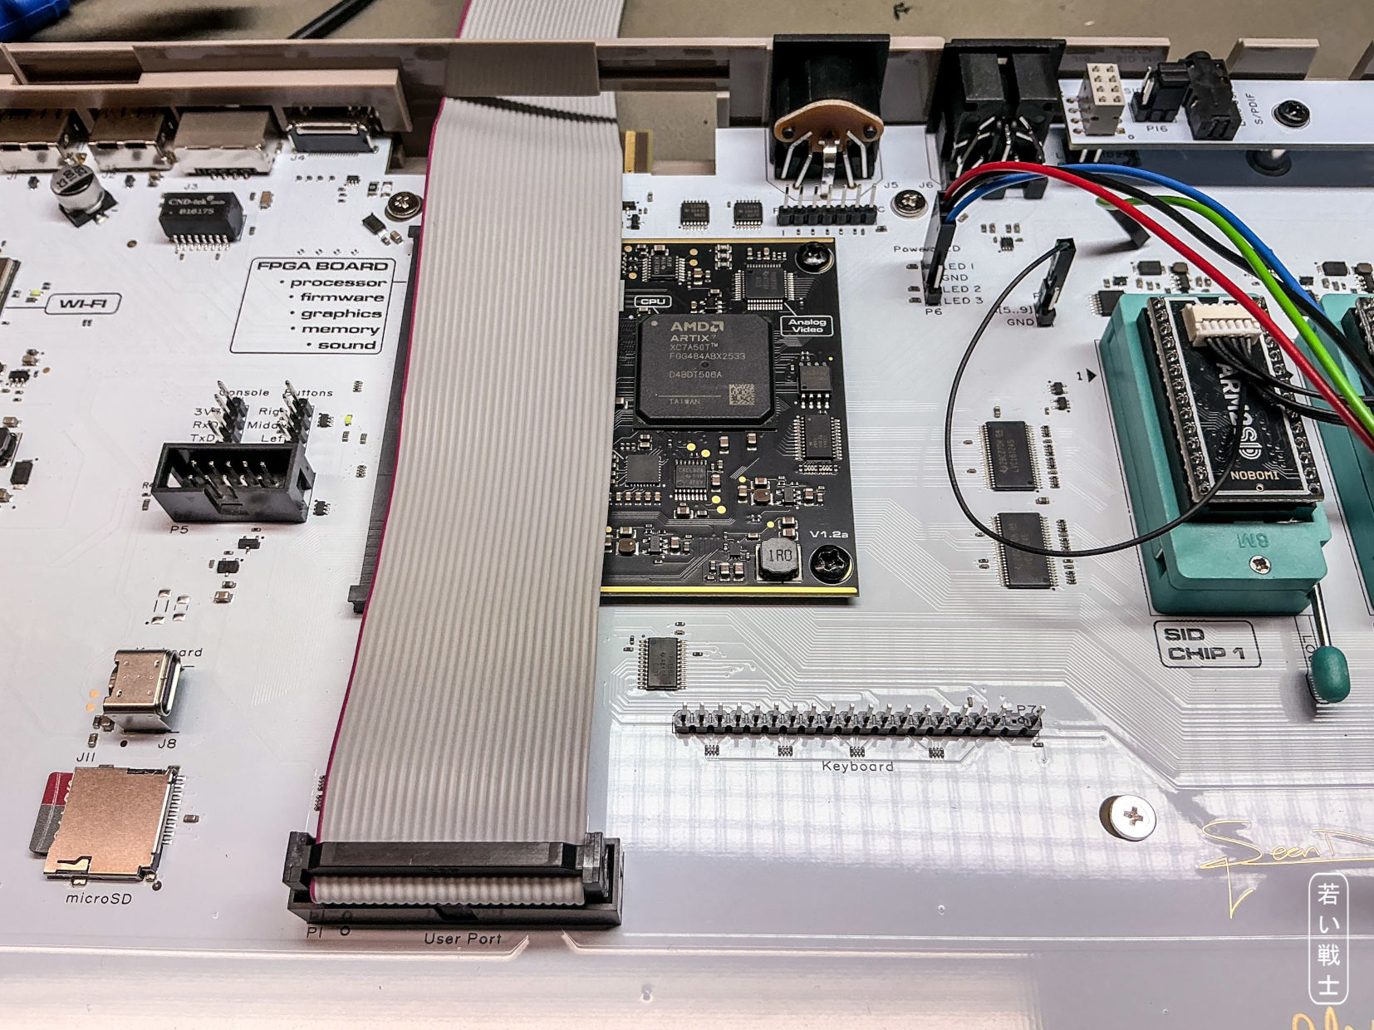
Figure 1: User Port ribbon cable inside a C64 Ultimate
As a result, the card edge connector and the pin header solder joints are exposed to the risk of short circuits and electrostatic discharge. The User Port case is designed to minimize these risks and to provide a neat, finished appearance.
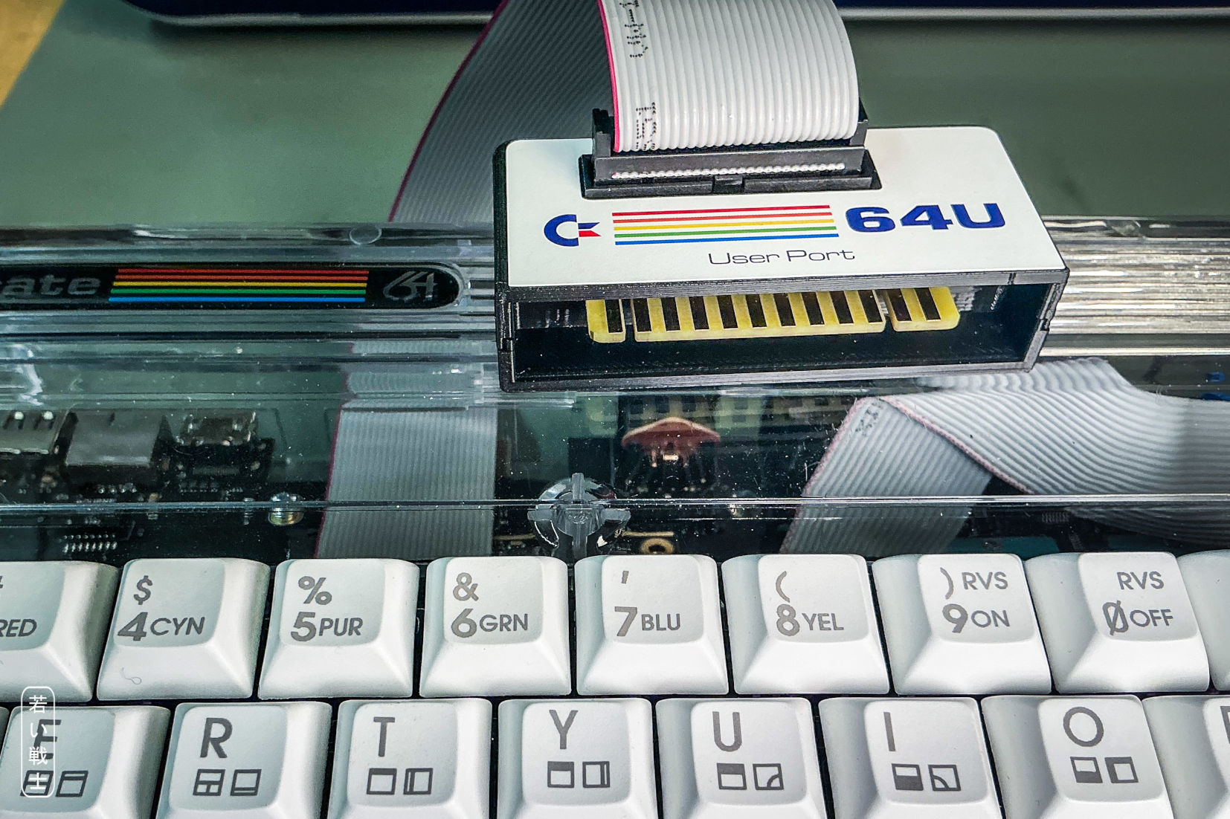
Figure 2: User Port Case on an Ultimate 64
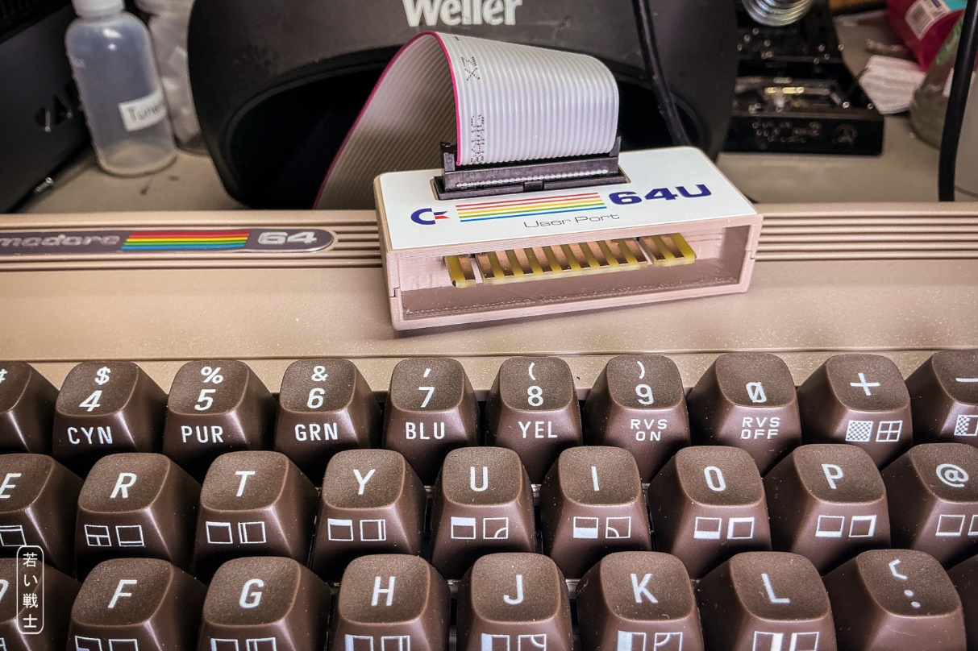
Figure 3: User Port Case on a C64 Ultimate
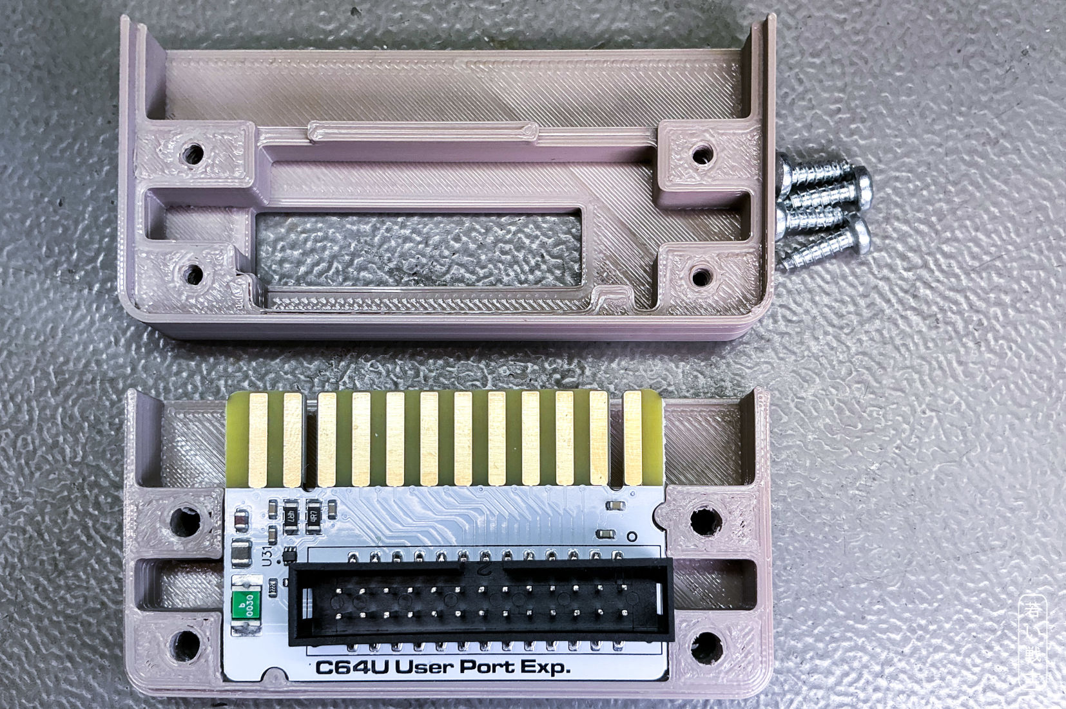
Figure 4: User Port PCB inside the open case
The User Port PCB is held securely and firmly inside the User Port case. The recommended screws are four each of 2.9mm x 9.5mm (self-taping) screws for sheet metal (C 2,9x9,5H, DIN 7981).
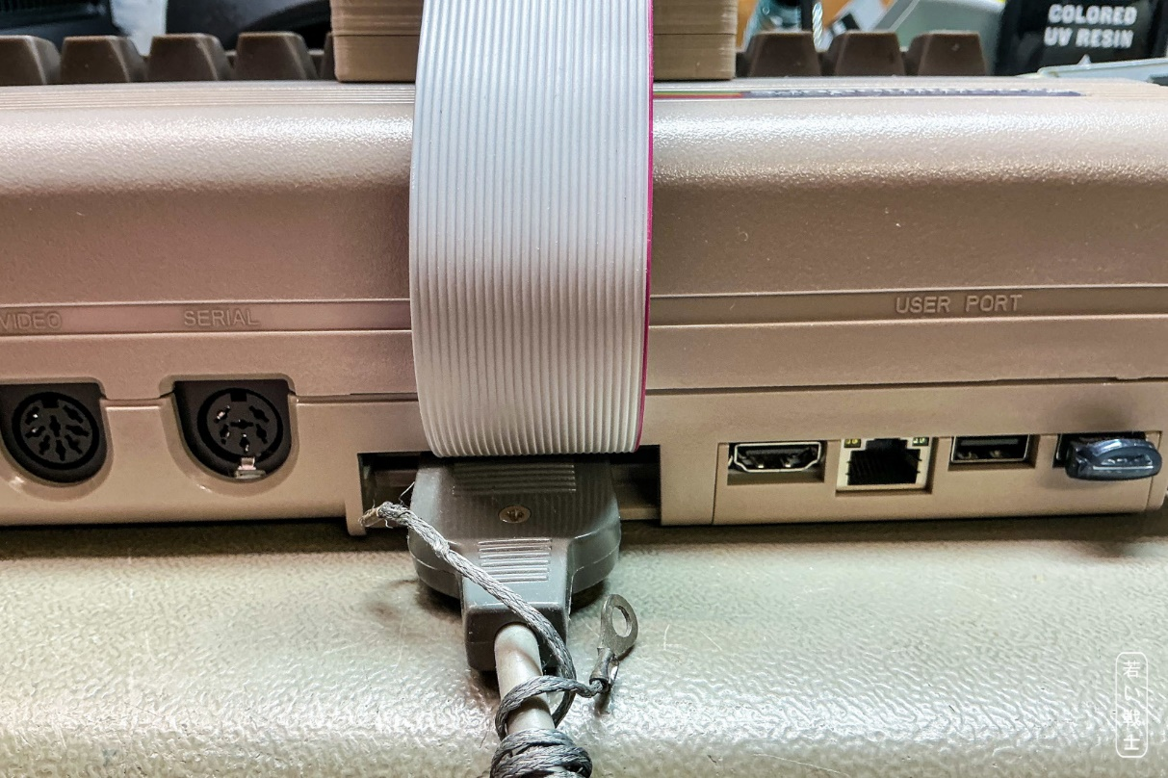
Figure 5: Cassette Port with ribbon cable and Datassette connector
The ribbon cable does not block the use of a Datasette.

Revision History

Rev. 0
The enclosure fits its purpose.

